**W02 Notes**

*JavaScript Novice to Ninja Chapter 2*

<https://www.sitepoint.com/premium/books/javascript-novice-to-ninja-2nd-edition/read/1>

*Random but cool things I learned*

* There are programs that take the comments from your code and make documentation.
  + <https://code.google.com/archive/p/jsdoc-toolkit/>
  + <http://ashkenas.com/docco/>
  + <http://yui.github.io/yuidoc/>
* It is not necessary to end a line in JavaScript with a semicolon because JavaScript interpreters insert it for you. However, it is error-prone so that is why it is best practice to always insert a semicolon at the end of a line.
* You can use as much whitespace as you want to format your code.
* ES6 uses const and let to declare variables. Var is old, but is not deprecated from the language. Let and const have block scope, which helps to avoid many problems. If you declare a variable outside of a block, it has global scope. Global scope is not considered good practice. Keep them to a minimum.
* You can use the backtick character to use both quote marks within a string.

*Symbols (This is awesome!!!! It is just what I needed at work.)*

* Symbols allow you to create a unique id. This helps if you need to write your code so that it doesn’t influence another open webpage, especially one that uses the same script.

***Chapter 3***

*Arrays*

* You can use the delete operator to remove a value from an array. Its value will be replaced by undefined.

*Sets* are arrays that delete duplicate values. This could be useful as well.

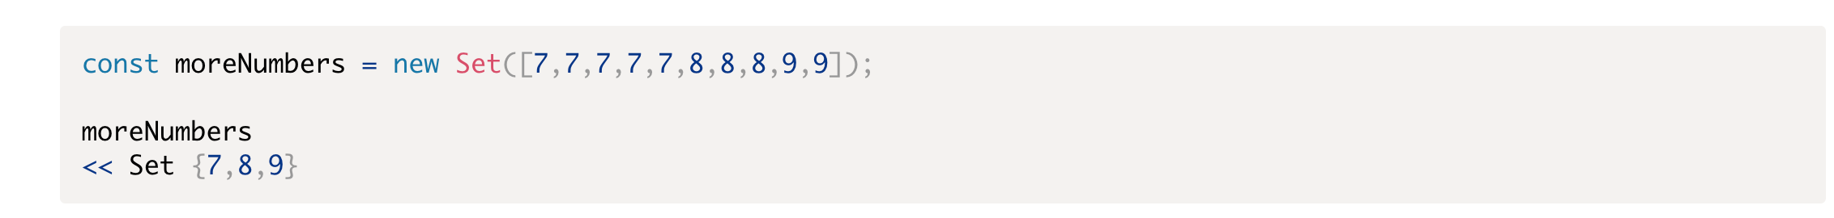

To remove duplicates from an array, you can make it a set and then turn it back into an array.

Maps are dictionaries that map keys and values.

*Logic*

You can use the for of loop to loop over an array in a simpler way

***Chapter 4: Functions***

An alternative way to declaring functions is to declare them inside of a variable. I can see this being useful when you need to pass the function in as a parameter of an onclick event in a string.

DRY – Don’t repeat yourself. Every part of a program should only be written once.

The difference between a parameter and an argument.



In other words, parameters are the variables and the arguments are the values the variables are assigned.

If you have a function that you don’t know how many arguments will be passed into it…

Note that args can be replaced with any word.

Default parameters should always come after non-default parameters.

**Function hoisting**

This means that you can use a function before it is defined if you use the function keyword.

Variables with var keyword will be hoisted, butt he assignment is not hoisted.

**Callbacks**

You can pass in a function as an argument of another function. This is called a callback.

You can use the .forEach() method to iterate over an array. You can also use .map() to iterate over elements in an array and replace the values with something else.



**Questions**

* What are some real-world problems that would require Sets and Symbols?

jhh